

**BADMINTON COURT BOOKING PLATFORM**

**Software Requirement Specification**

– Ho Chi Minh, May 2024 –

**Record of changeS**

|  |  |  |  |
| --- | --- | --- | --- |
| **Date** | **A* M, D** | **In charge** | **Change Description** |
| 18/May | A | ThinhND | Điền nội dung ở phần Overview Introduction (I.1) |
| 18/May | A | NganPD | Chèn hình ảnh ở phần Entity relationship |
| 18/May | A | NganPD | Thêm nội dung cho phần Entity Description |
| 18/May | A | SonVT | Điền nội dung ở phần Non-Screen Function |
| 18/May | A | ThinhND | Chèn hình ảnh của của Screen Flow (II.2.a) |
| 21/May | A | ThinhND | Chèn hình ảnh ở phần Context Diagram |
| 23/May | D | ThinhND | Xóa hình ảnh ở phần Context Diagram |
| 23/May | U | ThinhND | Cập nhật lại hình ảnh cho phần Context Diagram |
| 23/May | U | NganPD | Chỉnh sửa hình ảnh ở phần Screen Flow |
| 23/May | A | NamDP | Thêm hình ảnh ở phần Screen Flow cho role Staff |
| 23/May | A | SonVT | Thêm hình ảnh ở phần Screen Flow cho role Manager |
| 23/May | A | NganPD | Thêm hình ảnh ở phần Screen Flow cho role Admin |
| 23/May | A | ThinhND | Điền nội dung ở phần Screen Detail |
| 23/May | D | NganPD | Xóa hình ảnh ở phần ERD |
| 23/May | A | NganPD | Thêm hình ảnh phần ERD |
| 23/May | U | NganPD | Cập nhật lại Entities Description |
| 26/May | D | NganPD | Xóa hình ảnh của Screen Flow |
| 26/May | A | NamDP | Thêm hình ảnh ở phần Screen FLow cho role Customer |
| 26/May | A | SonVT | Thêm hình ảnh ở phần Screen Flow cho role Staff |
| 26/May | A | NganPD | Thêm hình ảnh ở phần Screen Flow cho role Admin |
| 26/May | A | SonVT | Thêm hình ảnh ở phần Screen Flow cho role Manager |
| 26/May | U | NganPD | Cập nhật lại Screen Detail |
| 26/May | U | SonVT | Cập nhật lại Screen Detail |
| 27/May | A | NganPD | Thêm chi tiết vào User Authorization |
| 27/May | U | SonVT | Cập nhật nội dung của Screen Detail |
| 27/May | A | NamDP | Cập nhật hình ảnh cho Functional Requirement |
| 27/May | A | NamDP | Thêm nội dung cho phần HomePage (II.1) |
| 27/May | A | NamDP | Thêm nội dung cho phần CourtService (II.2) |
| 27/May | A | NamDP | Thêm nội dung cho phần Sign in and Sign up (II.3) |
| 27/May | A | NganPD | Thêm nội dung cho phần Manager Feature (II.4) |
| 27/May | A | ThinhND | Thêm nội dung cho phần Staff Feature (II.5) |

*A - Added M - Modified D - Deleted

**Table of Contents**

I. Overview 4

1. Introduction 4

2. System Functions 5

3. Entity Relationship Diagram 6

II. Functional Requirements 7

1.Home Page 7

a.HomePage 7

2. Court Service

a.Find Court

b. Book Court………………………………………………………………………………………………………………………………….

c. Payment……………………………………………………………………………………………………………………………………….

3. Sign in and Sign up

1. Sign in
2. Sign up
3. User Profile

4. Manager Feature:

1. Manage Schedule
2. Slot Registration

5. Staff Feature:

1. Booking List
2. Yard List
3. Check-in

# I. Overview

## 1. Introduction

1. **Purpose:**

The "Badminton Court Booking Platform" project aims to develop an online system that enables customers to easily search, book, and pay for badminton courts. The system provides detailed court information, supports diverse booking options, and offers secure online payment. It also includes management functions for court managers and staff, such as updating information, managing booking schedules, performing check-ins, and monitoring court status. The admin has the authority to manage the entire system and user accounts.

1. **User Roles:**

* **Guest**: Users who search for courts but haven't registered an account
* **Customer**: Badminton players who have registered an account and booked a court
* **Court Manager**: Managers responsible for updating court information and managing booking schedules
* **Court Staff**: Staff at the court who assist with check-ins and monitor court status
* **System Admin**: Administrators who manage the entire system and user accounts

1. **Project Scope:**

* Search and view court information
* Book court sessions
* Online payment
* Court management
* Check-in
* Manage user accounts and court information

1. **Assumptions and Constraints:**

* Online Payment Requirement: Users must have a bank account or use supported electronic payment methods.
* Accurate Court Information: Court managers are responsible for providing and maintaining accurate court information.
* Information and Transaction Security: The system must ensure the security of user information and transactions.
* Third-Party Services: The system will utilize third-party services like electronic wallets.
* Court staff and managers will be fully trained to effectively use the system, including managing bookings and performing check-ins.
* User-Friendly Interface: The system should be intuitive and user-friendly.

>>

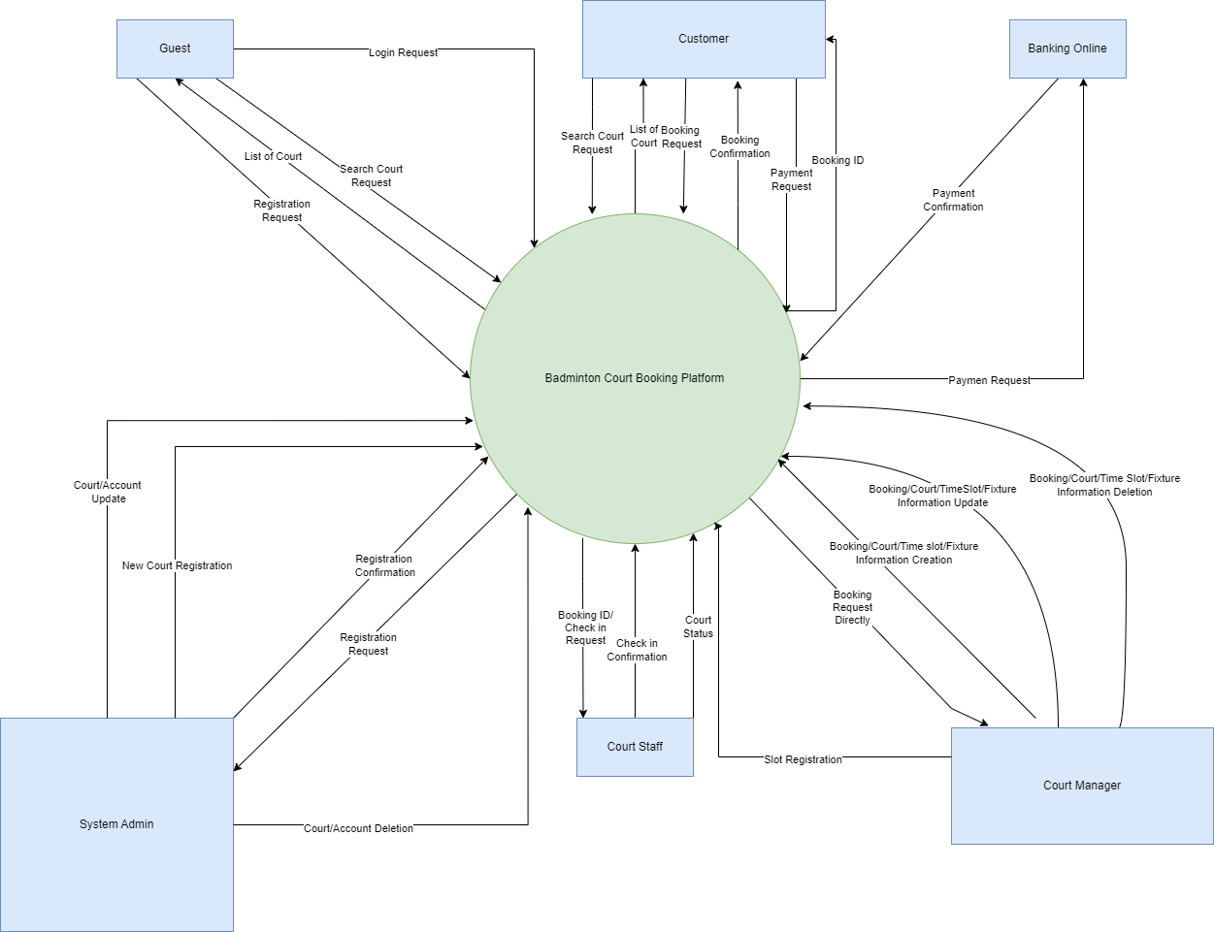

## 2. System Functions

#### a. Screen Flow

* Customer/Player:

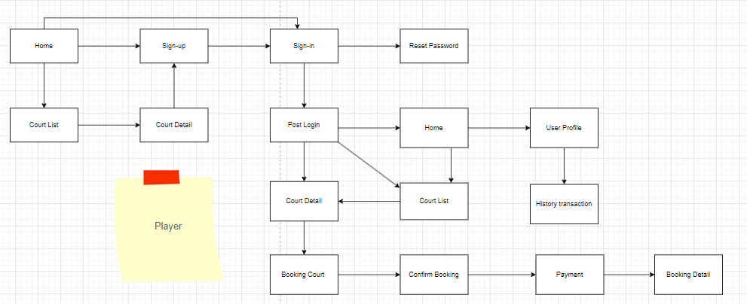

* Court Staff:

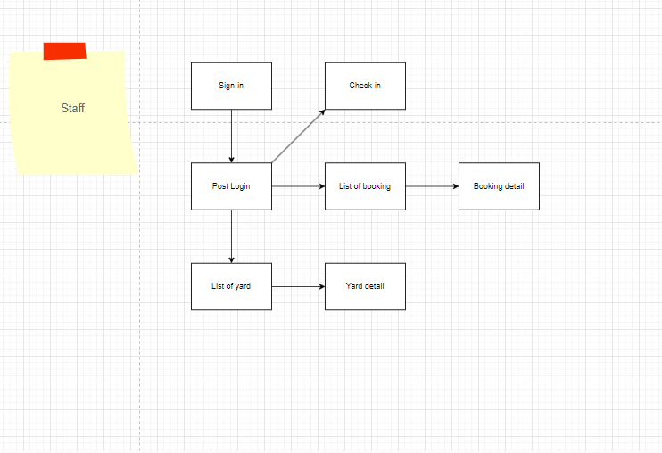

* Court Manager:

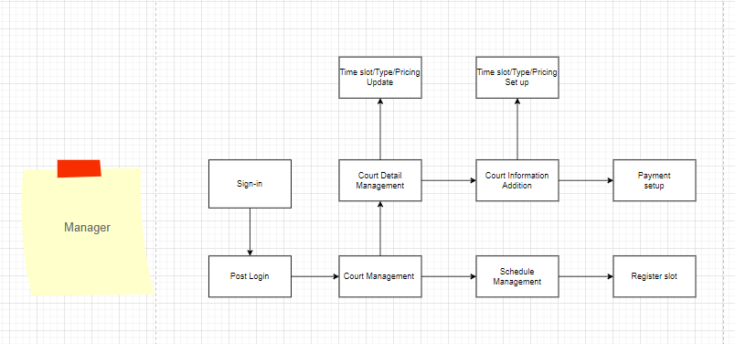

* System Admin:

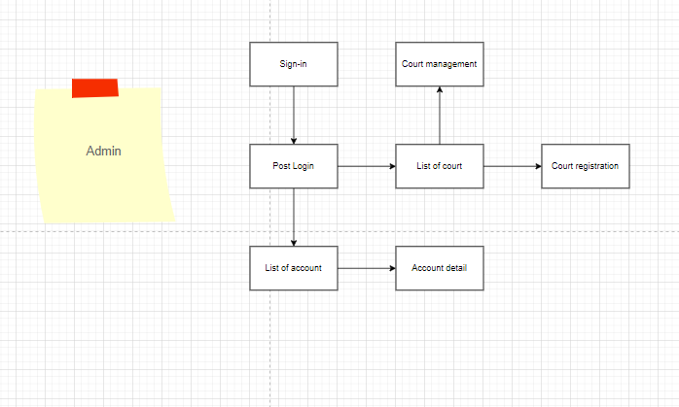

#### b. Screen Details

|  |  |  |
| --- | --- | --- |
| Feature | Screen | Description |
| Register | Sign Up | Allows users to create a new account by entering personal information such as name, email, password, etc. |
| Login | Sign In | Users input login information (email and password) to access their registered account. |
| Reset Password | Reset Password | Enables users to request a password reset if they forget their current password. |
| Find Court | Court List | Enable users to find a list of Badminton courts by City, Province, Price, Operating hours or Name courts. |
| Display court list | Court List | Displays a list of Badminton courts by City, Province, Price, Operating hours or Name courts. |
| Find Court | Home page | Displays a list of Badminton courts by City, Province, Price, Operating hours or Name courts. |
| Display Court Detail | Court Detail | Provides detailed information about a specific Badminton court. This may include images, pricing, address, etc. |
| Display Profile | User Profile | Shows user’s personal information, including name, profile picture, etc. |
| Display history transaction | History Transaction | Shows the user's transaction and information of booking which was done. |
| Book Court | Booking Court | Allows users to select a tennis court and booking time. Payment may be required before or after booking. |
| Confirm Booking | Confirm Booking | Displays information about the selected booking. Users confirm their reservation here. |
| Cancel Booking | Confirm Booking | Enable users to delete all choices and return to the Court List screen in booking if they don’t want to use the service. |
| Display transaction | Payment | Shows price details and payment methods. Users complete the payment process. |
| Display Booking Detail | Booking Detail | Provides detailed information about a completed booking. Includes details about the court, time, price, etc. |

|  |  |  |
| --- | --- | --- |
| Feature | Screen | Description |
| Login | Sign-in | Allows administrators to sign in to their account by inputting their credentials (username and password). |
| Display account list | Account List | Shows a list of user accounts. Administrators can view and manage user accounts from this screen. |
| Display account detail | Account detail | Displays detailed information about a specific user account, including details such as name, email, role, etc. |
| Manage account detail | Account detail | Manage the information( the staff will note the information of the player in to the system) |
| Display court list | Court List | Shows a list of courts (possibly Badminton courts). Administrators can view court details, availability, and other relevant information. |
| Register court | Court registration | Allows administrators to register new courts. They input court details (name, location, capacity, etc.) to add a new court to the system. |

|  |  |  |
| --- | --- | --- |
| Feature | Screen | Description |
| Login | Sign-In | Allows managers to log in to the system using credentials (e.g., username and password). |
| Display Time Slot/Type/Pricing Update | Time Slot/Type/Pricing Update | Enables managers to manage time slots, court types, and pricing information. |
| Manage court deal | Court Deal Management | Handles special deals or promotions related to court bookings (e.g., discounts during off-peak hours). |
| Add court information | Court Information Addition | Allows managers to add or update details about individual courts (dimensions, surface type, rules). |
| Setup payment method | Payment Setup | Configures payment methods and gateways for secure court booking payments. |
| Manage Court | Court Management | Provides an overview of all courts (availability, occupancy, upcoming bookings). |
| Manage Schedule | Schedule Management | Manages court schedules, reservations, cancellations, and waitlists. |
| Register Slot | Slot registration | Allows managers to register for specific time slots on a court. |

|  |  |  |
| --- | --- | --- |
| Feature | Screen | Description |
| Login | Sign-In | Allows staff to log in to the system using credentials (e.g., username and password). |
| Display yard list | List of Yard | Staff can view details about different yards (e.g., facilities, availability, specifications). |
| Display yard detail | Yard Detail | Provides in-depth information about a specific yard (e.g., dimensions, surface type, rules). |
| Display booking list | List of Booking | Staff can access detailed information about bookings (e.g., reservations, schedules). |
| Display booking detail | Booking Detail | Displays specifics of a particular booking (e.g., date, time, customer details). |
| Manage booking detail | Booking Detail | Enable staff can cancel or update status of booking details. |
| Check-In | Check-In | Allows staff to perform check-ins for bookings (e.g., verifying customer arrivals). |

#### c.User Authorization

|  |  |  |  |  |  |
| --- | --- | --- | --- | --- | --- |
| **Screen** | **Guest** | **Customer** | **Court Staff** | **Court Manager** | **System Admin** |
| Home Page | X | X | X | X | X |
| Find court | X | X | X | X | X |
| Sign-in | X | X | X | X | X |
| Login | X | X | X | X | X |
| Reset password | X | X |  |  |  |
| Sign-up | X | X |  |  |  |
| Register | X | X |  |  |  |
| Court list (Guest/Customer) | X | X |  |  |  |
| Find courts | X | X |  |  |  |
| Display court list | X | X |  |  |  |
| Court detail | X | X |  |  |  |
| Display court detail | X | X |  |  |  |
| User profile |  | X |  |  |  |
| Display profile |  | X |  |  |  |
| Display history transaction |  | X |  |  |  |
| Booking court |  | X |  |  |  |
| Book court |  | X |  |  |  |
| Confirm booking |  | X |  |  |  |
| Confirm booking |  | X |  |  |  |
| Cancel booking |  | X |  |  |  |
| Payment |  | X |  |  |  |
| Display transaction |  | X |  |  |  |
| Booking detail (Customer) |  | X |  |  |  |
| Display booking detail |  | X |  |  |  |
| Account list |  |  |  |  | X |
| Display account list |  |  |  |  | X |
| Court list (Administrator) |  |  |  |  | X |
| Display court list |  |  |  |  | X |
| Court registration |  |  |  |  | X |
| Court register |  |  |  |  | X |
| Time Slot/Type/Pricing Update |  |  |  | X |  |
| Display Time Slot/Type/Pricing Update |  |  |  | X |  |
| Court Deal Management |  |  |  | X |  |
| Manage court deal |  |  |  | X |  |
| Court Information Addition |  |  |  | X |  |
| Add court information |  |  |  | X |  |
| Payment Setup |  |  |  | X |  |
| Setup payment method |  |  |  | X |  |
| Court Management |  |  |  | X |  |
| Manage court |  |  |  | X |  |
| Schedule Management |  |  |  | X |  |
| Manage schedule |  |  |  | X |  |
| Slot Registration |  |  |  | X |  |
| Register slot |  |  |  | X |  |
| List of Yard |  |  | X |  |  |
| Display yard list |  |  | X |  |  |
| Yard Detail |  |  | X |  |  |
| Display yard detail |  |  | X |  |  |
| List of Booking |  |  | X |  |  |
| Display booking list |  |  | X |  |  |
| Booking Detail (Court Staff) |  |  | X |  |  |
| Manage booking detail |  |  | X |  |  |
| Display booking details |  |  | X |  |  |
| Check-In |  |  | X |  |  |
| Check-in |  |  | X |  |  |

#### d. Non-Screen Functions

|  |  |  |  |
| --- | --- | --- | --- |
| **#** | **Feature** | **System Function** | **Description** |
| 1 | Automatic Reminders & Notifications | ReminderService | Sends email or SMS reminders to customers about their upcoming bookings, cancellations, or payment deadlines. |
| 2 | Court Availability Updates | Availability Update Service | Automatically updates court availability based on bookings and cancellations, ensuring accurate information for customers. |
| 3 | Payment Processing | PaymentGatewayAPI | Integrates with a payment gateway (MoMo, internet banking,...) to securely process payments for bookings |

## 3. Entity Relationship Diagram

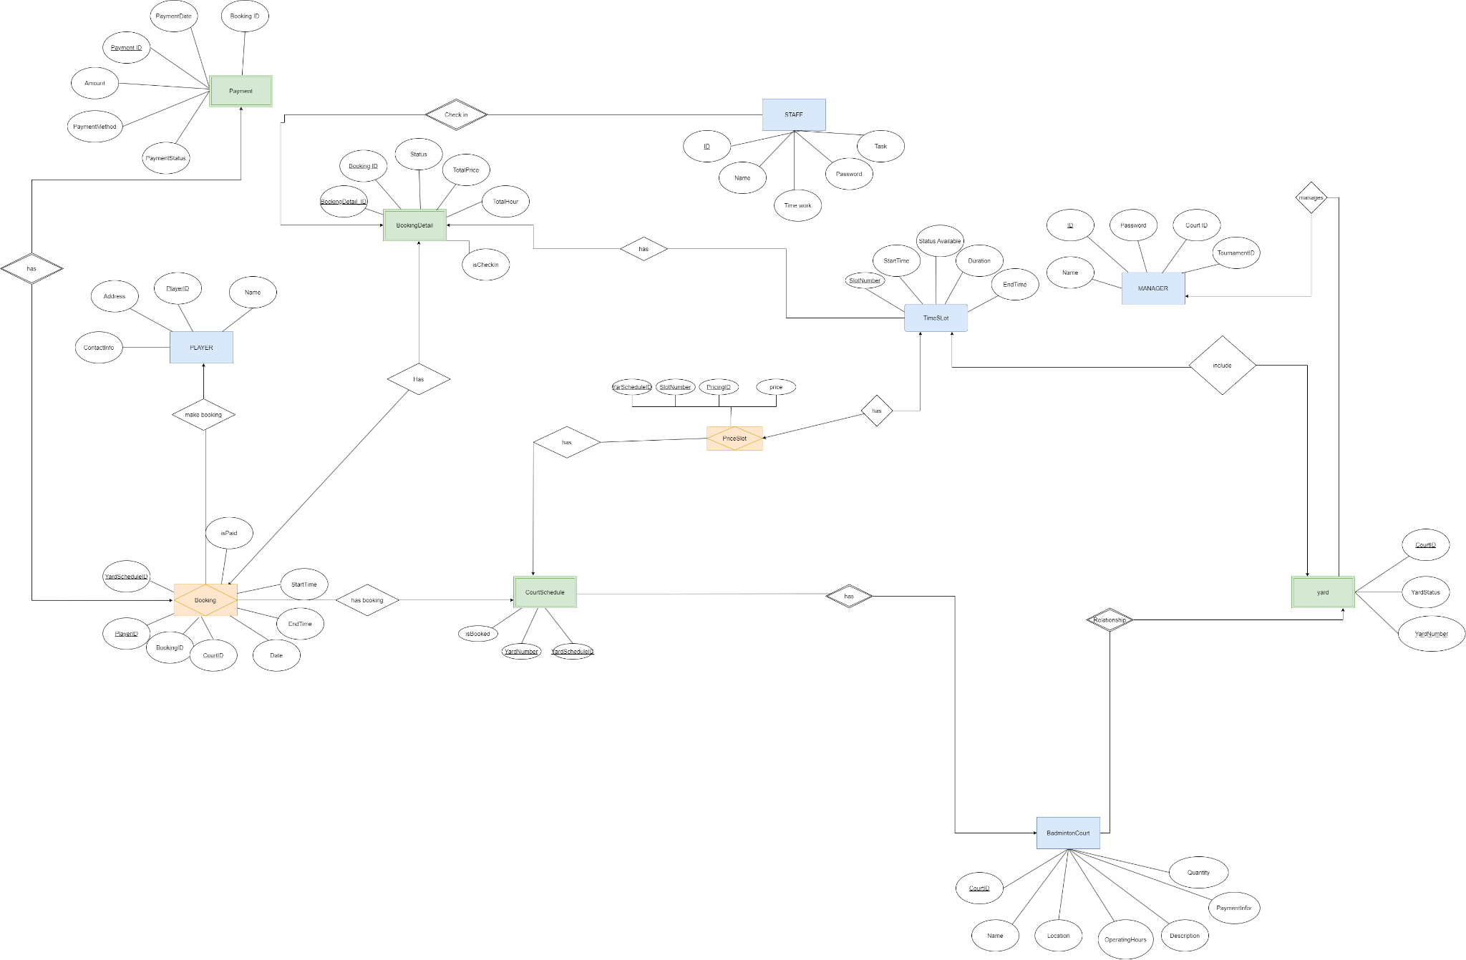

**Entities Description**

| **#** | **Entity** | **Description** |
| --- | --- | --- |
| 1 | Player | Represents an individual who engages in playing badminton. Each player has a unique profile including personal details, contact information, and a history of their bookings and payments. |
| 2 | Booking | Captures the reservation details made by a player for a badminton court. It includes information about the player, the court, and the scheduled time. |
| 3 | PriceSlot | Defines the pricing structure for booking a badminton court. Prices may vary based on time of day, day of the week, and player membership status. |
| 4 | TimeSlot | Specifies the available time slots for booking badminton courts. Each slot represents a specific duration and time of day. |
| 5 | BadmintonCourt | Represents the physical badminton courts available for booking. Each court has a unique identifier and may have specific features or conditions. |
| 6 | Payment | Records the payment transactions made by players for their bookings. This entity tracks payment methods, amounts, and statuses. |
| 7 | Yard | Represents the overall facility or venue where multiple badminton courts are located. It includes details about the location and facilities available. |
| 8 | BookingDetail | Provides detailed information about a specific booking, including the players involved, equipment rented, and any additional services availed. |
| 9 | Staff | Represents employees working at the badminton facility. This entity includes information about their roles, schedules, and contact details. |
| 10 | Manager | Represents the managerial staff responsible for overseeing the operations of the badminton facility. Managers handle bookings, payments, staff, and overall facility maintenance. |
| 11 | CourtSchedule | Represents the schedule for each badminton court, detailing the availability and reservations for specific time slots. This entity helps manage and organise the booking slots for each court to ensure efficient utilisation and avoid conflicts. |

# II. Functional Requirements

## Home Page

### a. HomePage:

* Function Trigger: Accessed directly by the user (from browser URL
* Function Description:
* **Actors/Roles**: Guest, Customer, Court Staff, Court Manager, System Admin.
* **Purpose**: To display the main landing page of the platform, providing access to key features like finding courts, news, contact, sign in, and sign up (if a guest has no account or is not yet logged in as a customer, staff, manager, or admin)
* **Interface:** A visually appealing layout with clear navigation options, featuring:
  + Search bar for finding courts.
  + Information about the platform (e.g., about us, contact details).

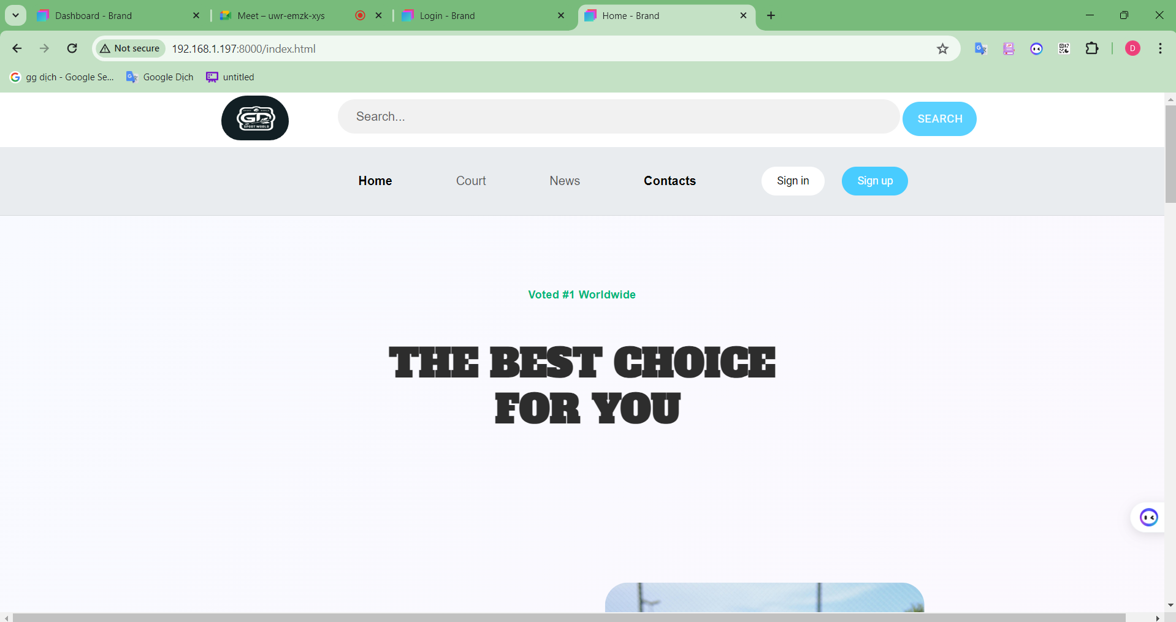

* **Function Details:**
  + Data: Dynamically loads relevant data based on the user's role and preferences (if logged in).
  + Validation: None, as this is a general display screen.
  + Business Logic: Displays relevant content for each user role (e.g., promotional content for guests, booking history for customers, court management for court managers).
  + Abnormal Cases: Handle errors like server issues or loading failures gracefully by displaying error messages or fallback content.

## 2. Court Service

### a. Find Court:

* Function Trigger: Accessed by clicking on "Court" on the homepage or from navigation menus.
* Function Description:
* Actors/Roles: Guest, Customer, Court Staff, Court Manager, System Admin.
* Purpose: To allow users to search for available badminton courts based on various criteria.
* Interface:
  + Search bar with filters for location, availability (date/time), court type, and other relevant criteria.
  + Display of a list of courts matching the search criteria, including court name, location, available slots, and price.
  + Option to view detailed information about each court.

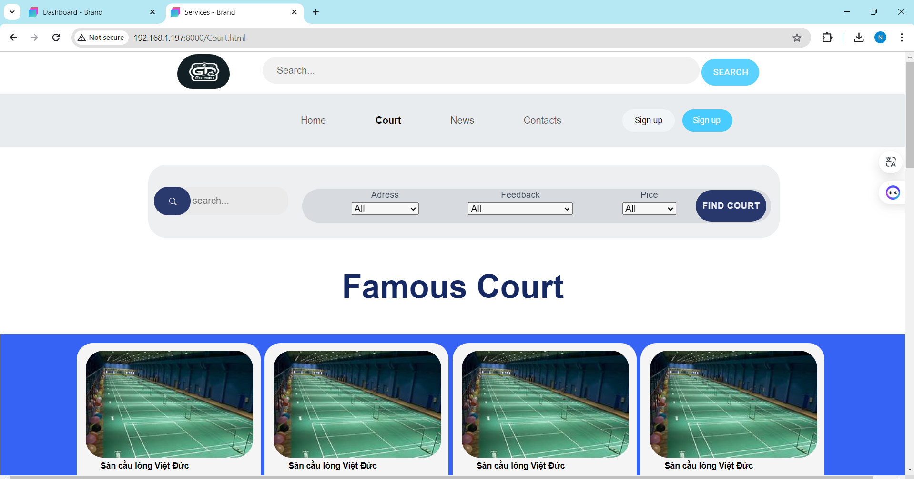

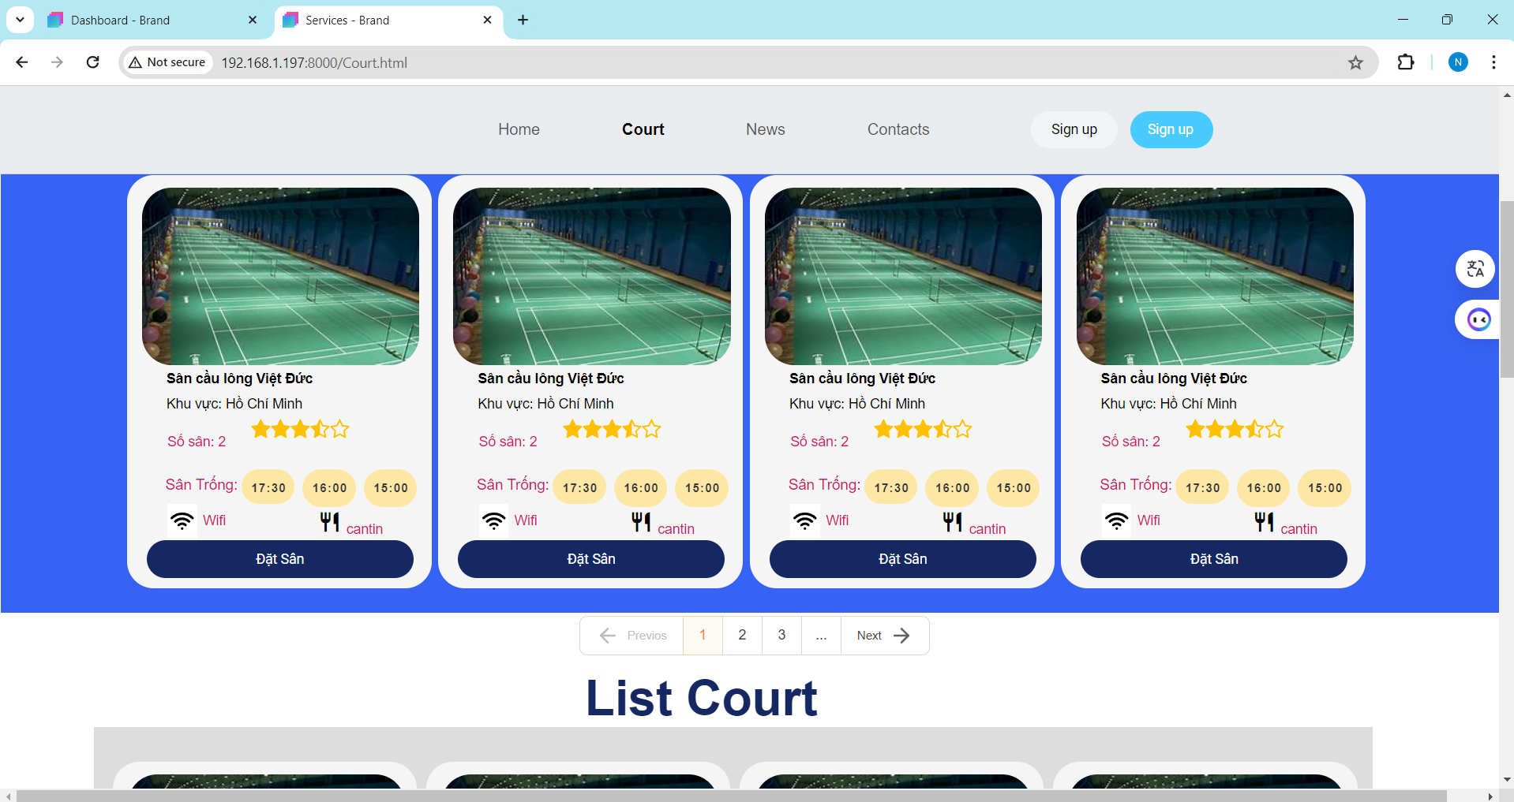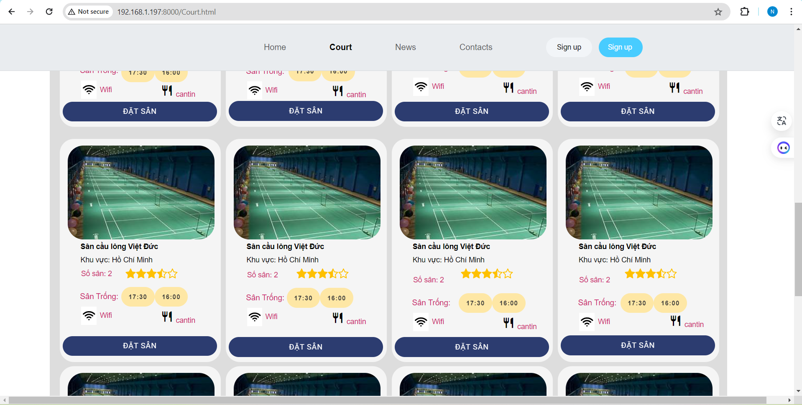

* Function Details:
  + Data: Dynamically loads relevant data based on the user's role and preferences (if logged in).
  + Validation: None, as this is a general display screen.
  + Business Logic: Displays relevant content for each user role (e.g., promotional content for guests, booking history for customers, court management for court managers).
  + Abnormal Cases: Handle errors like server issues or loading failures gracefully by displaying error messages or fallback content.

**b. Book Court:**

* Function Trigger: User clicks on "Book Now" button on the Court Detail page.
* Function Description:
  + Actors/Roles: Customer.
  + Purpose: To allow users to book a court based on available slots.
* Interface:
  + Display of the selected court's information (name, location, price).
  + Availability calendar with highlighted available slots.
  + Option to choose a specific booking type (fixed, daily, flexible).
  + Input field for start time and duration (if required).
  + Choose the preferred court.
  + Check the yard information that the user wants to place in the cart
  + "Thanh Toan" button.

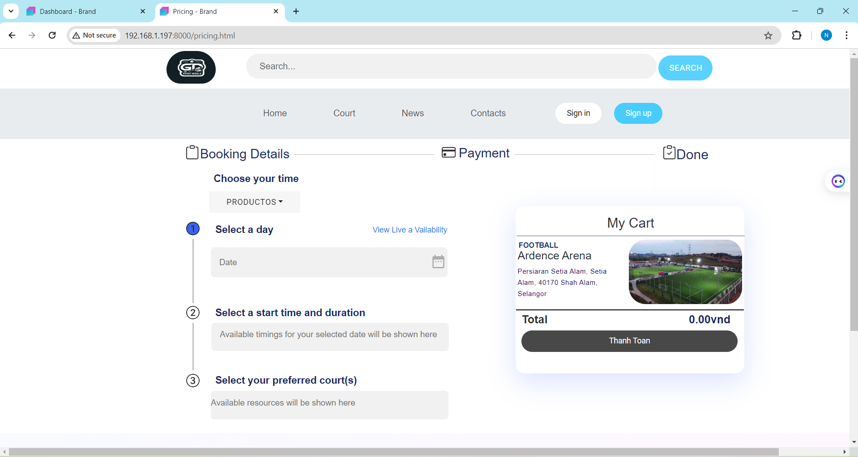

**C.** **.Payment:**

* Function Trigger: Accessed by clicking on "Thanh Toan" from the booking detail page.
* Function Description:
  + Actors/Roles: Customer.
  + Purpose: To allow users to make payments for bookings.
* Interface:
  + Option to choose a payment method (e.g., credit card, online banking, etc.).
  + "Start Subcription" button.

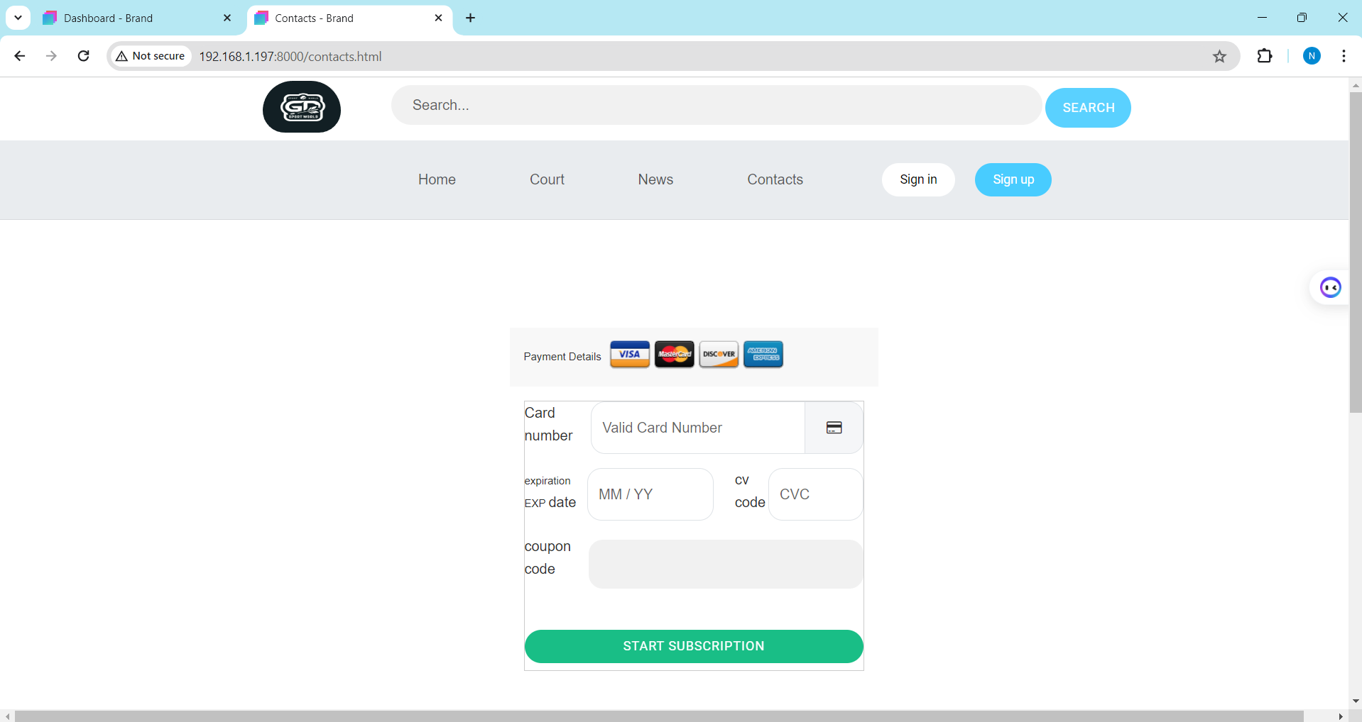

* Function Details:
  + Data: Retrieves booking details from the database.
  + Validation: Validates the chosen payment method and ensures sufficient funds are available.
* Business Logic:
  + Redirects the user to the payment gateway (e.g., Stripe, PayPal) to complete the transaction.
  + Updates the booking status to "paid" upon successful payment.

## 3. Sign In and Sign Up

### a. Sign In

* Function Trigger: User enters credentials and clicks "Sign In".
* Function Description:
* Actors/Roles: Guest, Customer, Court Staff, Court Manager, System Admin.
* Purpose: To verify user credentials and allow access to the platform.
* Interface:
  + Input fields for email/username and password.
  + "Sign In" button.
  + "Forgot Password" link.

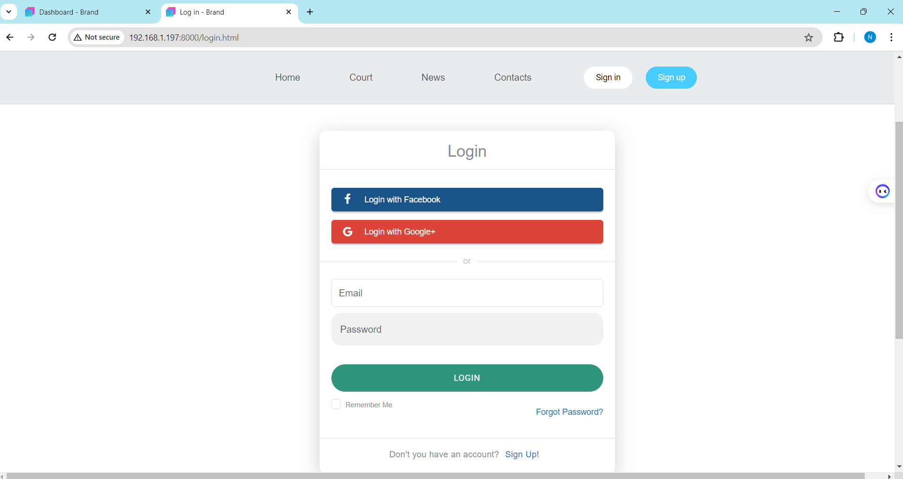

* Function Detail:
  + Data: Retrieves user credentials from the database.
  + Validation: Validates email/username and password input for correct format and length.
  + Business Logic:
    - Checks if the provided credentials match a registered user in the database.
    - Redirects to the user's homepage or profile page if successful.
  + Abnormal Cases: Handles errors like invalid credentials, account not found, or security issues with appropriate error messages.

### b. Sign Up:

* Function Trigger: User fills out the form and clicks "Sign Up".
* Function Description:
  + Actors/Roles: Guest.
  + Purpose: To register a new user account on the platform.
* Interfaces:
  + Input fields for email/username, password, and other required information (e.g., name, phone number, etc.).
  + "Sign Up" button.

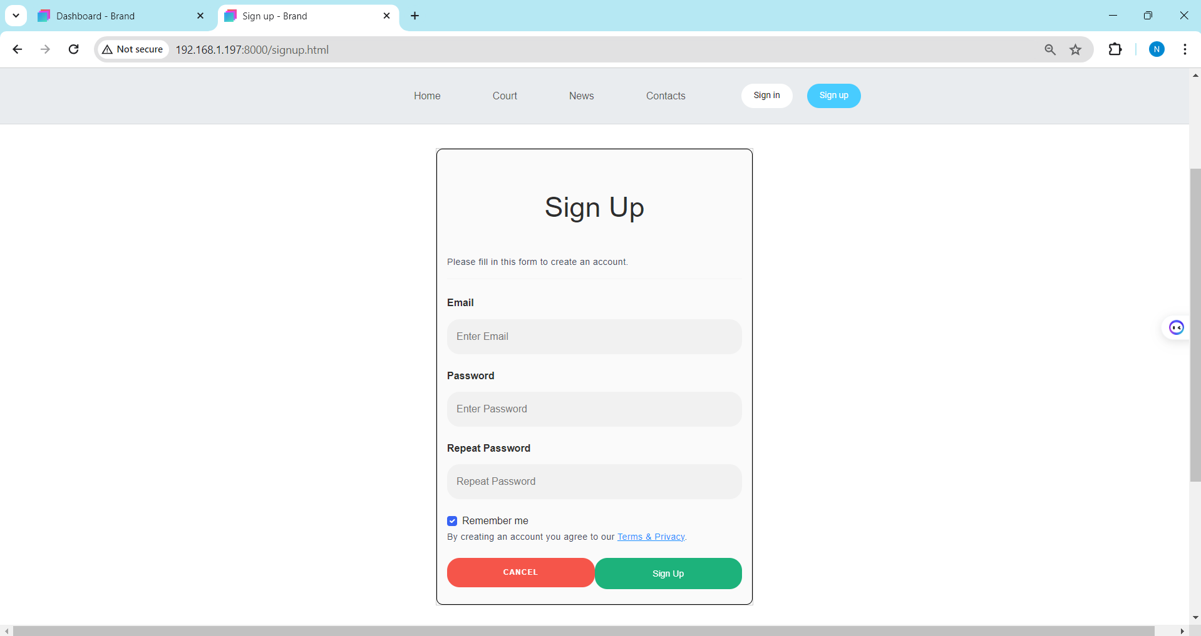

* Function Details:
  + Data: Retrieves user credentials from the database.
  + Validation: Ensures valid email/username and password format.
  + Business Logic:
    - Uses the provided credentials to verify the user's identity.
    - Stores user session data (e.g., user ID, role) for future authorization.
    - Redirects the user to their designated homepage (based on role).
  + Abnormal Cases: Handles errors like invalid credentials, account not found, or security issues.

### c. User Profile:

* Function Trigger: Accessed by clicking on "Profile" from the navigation menu or from the user's homepage.
* Function Description:
  + Actors/Roles: Customer.
  + Purpose: To display the user's profile information.
* Interface:
  + Basic profile information (name, email, phone number, etc.).
  + Booking history with details (court, date, time, price).
  + Option to edit profile information (update personal details, change password).
  + Link to "Booking Detail" page to view past and upcoming bookings.
* Screen Layout: not yet.
* Function Details:
  + Data: Retrieves user information and booking history from the database.
  + Validation: None, as this is a general display screen.
* Business Logic:
  + Displays the user's profile information dynamically.
  + Updates the profile information when the user edits their details.

## 4. Manager Feature:

### Manage Schedule:

* Function Trigger: Accessed by clicking on "Schedule Management" from the navigation menu on the admin dashboard.
* Function Description:
  + Actors/Roles: System Admin.
  + Purpose: To allow system admins to manage the overall court scheduling system, including default time slots, booking types, and pricing rules.
* Interface:
  + Display of default time slots, booking types, and their pricing.
  + Option to add, edit, or delete time slots and types.
  + Option to set default pricing for different types of bookings.

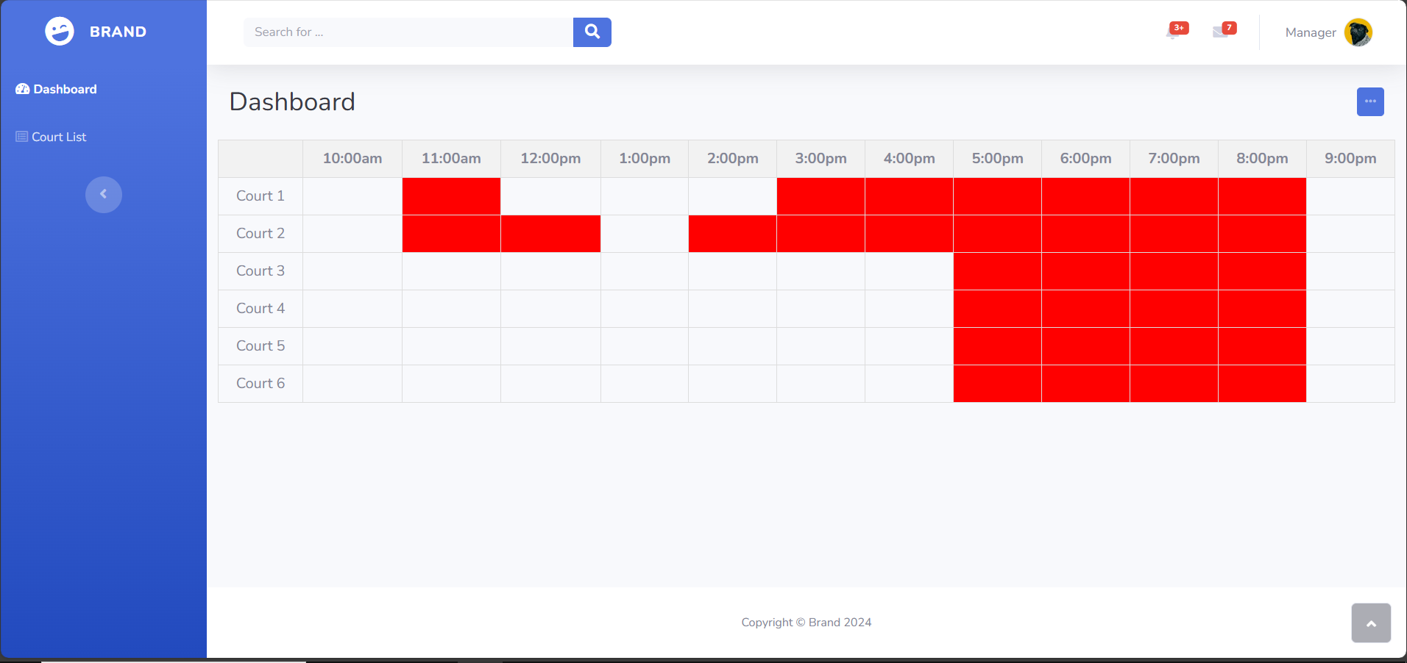

* Function Details:
  + Data: Retrieves schedule data from the database.
  + Validation: Ensures valid input for time slots, types, and pricing.
  + Business Logic:
    - Updates the scheduling system settings in the database.
    - Potentially updates court availability information based on the new settings.
  + Abnormal Cases: Handles errors like invalid input, database issues, or conflicts with existing bookings.

### Slot Registration:

* Function Trigger: Clicked on any empty box on the schedule.
* Function Description:
  + Actors/Roles: Court Manager.
  + Purpose: To allow court managers to register specific time slots for courts when customers come to book appointments directly.
* Interface:
  + Same as “Manage Schedule”.
* Function Details:
  + Data: Retrieves court information from the database.
  + Validation: Ensures valid input for date, time, duration, type, and price.
* Business Logic:
  + Creates a new time slot record in the database for the selected court.
  + Updates the court availability calendar to reflect the new slot.
* Abnormal Cases: Handles errors like invalid input, database issues, or conflicts with existing bookings.

1. Yard List:

* Function Trigger: Accessed by clicking on "List of Yard" from the navigation menu on the court staff dashboard.
* Function Description:
  + Actors/Roles: Court Staff.
  + Purpose: To display a list of all badminton courts managed by the court staff.
* Interface:
  + List of courts with basic information (name, Created date, status, action (View or Edit).
  + Option to view detailed yard information.
  + Option to edit yard information.

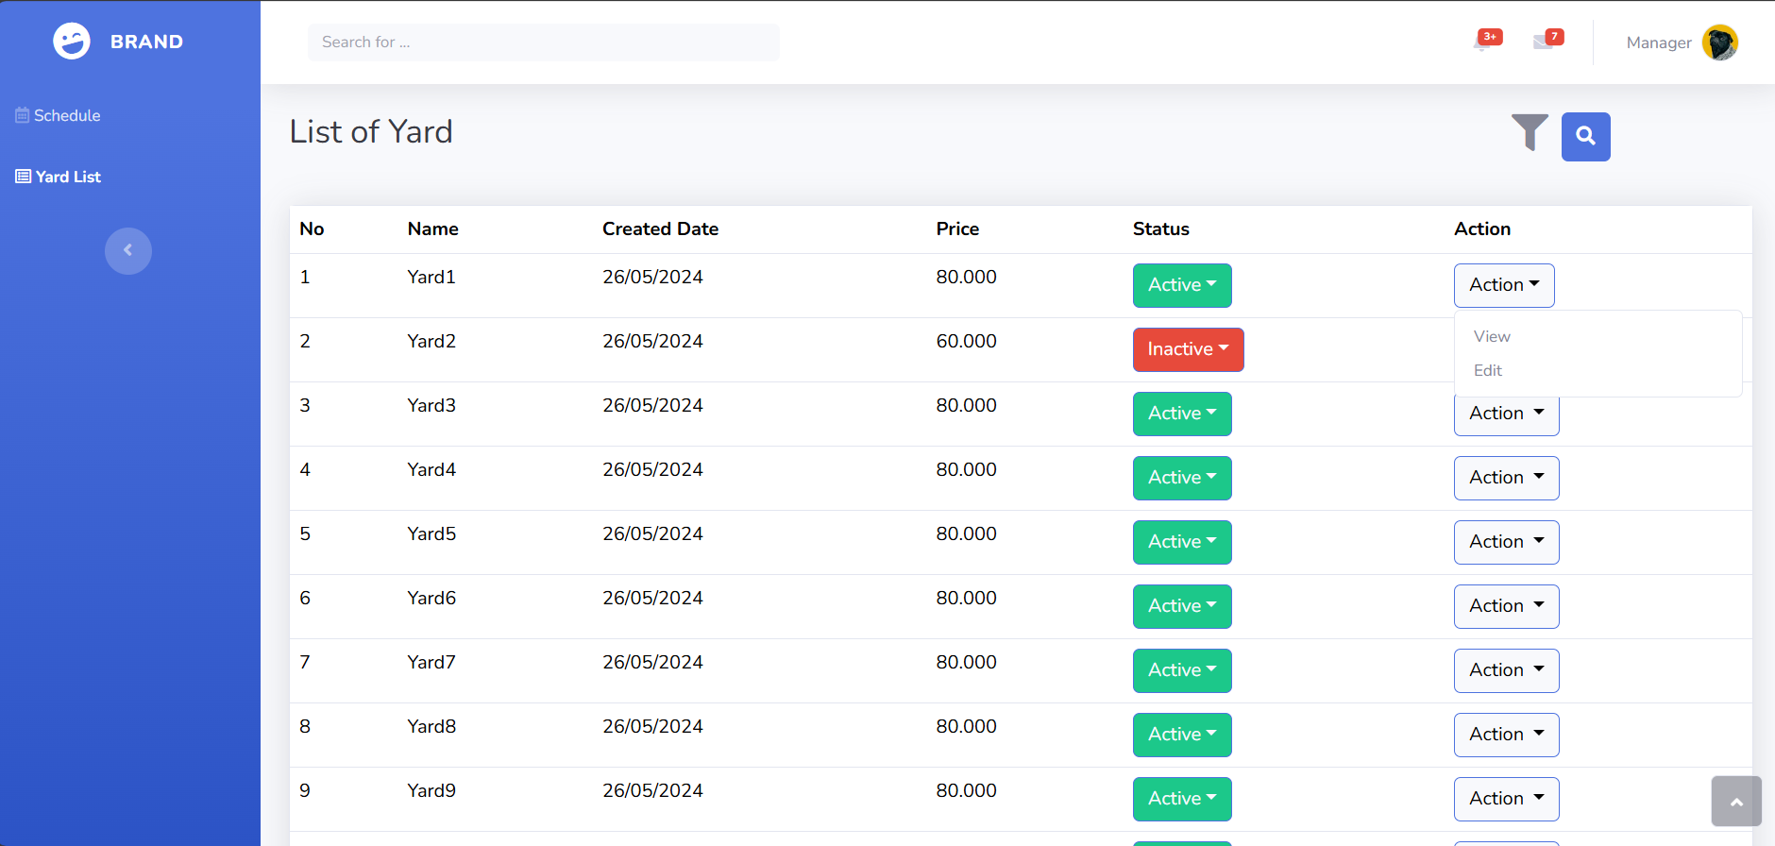

* Function Details:
  + Data: Retrieves court information from the database, associated with the court staff.
  + Validation: None, as this is a general display screen.
  + Business Logic:
    - Displays the list of courts dynamically.
    - Allows filtering and sorting of courts based on predefined criteria.
* Abnormal Cases: Handles errors like data retrieval issues or problems displaying the list.

## 5. Staff Feature:

### Booking List:

* Function Trigger: Accessed by clicking on "List of Booking" from the navigation menu on the court staff dashboard.
* Function Description:
  + Actors/Roles: Court Staff.
  + Purpose: To display a list of all bookings for the courts managed by the court staff.
* Interface:
  + List of bookings with basic information (customer name, booking date, status (check-in or cancel)).

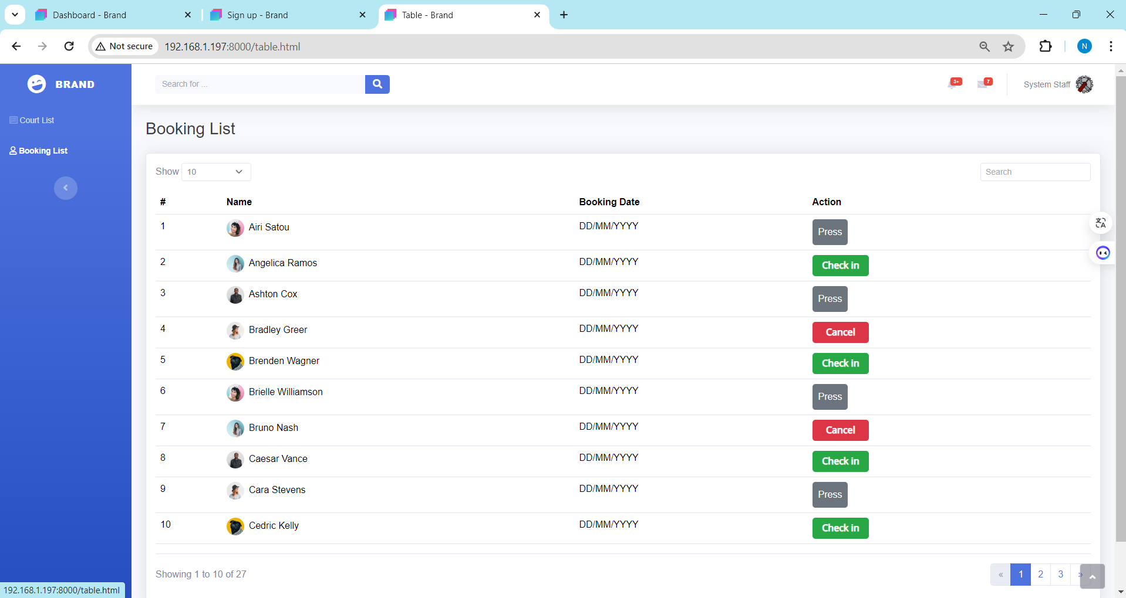

* Function Details:
  + Data: Retrieves booking information from the database associated with the court staff.
  + Validation: None, as this is a general display screen.
* Business Logic:
  + Displays the list of bookings dynamically.
  + Allows filtering and sorting of bookings based on predefined criteria.
* Abnormal Cases: Handles errors like data retrieval issues or problems displaying the list.

### Yard List:

* Function Trigger: Accessed by clicking on "List of Yard" from the navigation menu on the court staff dashboard.
* Function Description:
  + Actors/Roles: Court Staff.
  + Purpose: To display a list of all badminton courts managed by the court staff.
* Interface:
  + Same as “Yard List”.

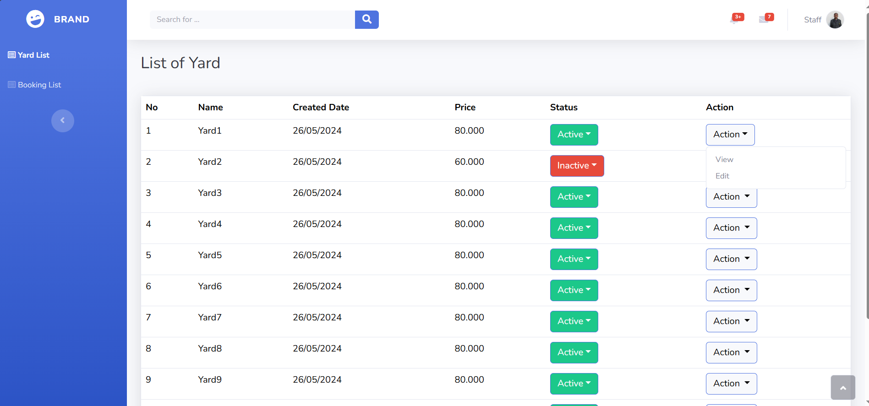

* Function Details:
  + Data: Retrieves court information from the database, associated with the court staff.
  + Validation: None, as this is a general display screen.
* Business Logic:
  + Displays the list of courts dynamically.
  + Allows filtering and sorting of courts based on predefined criteria.

### Check-in:

* Function Trigger: Accessed from the "Booking List" screen.
* Function Description:
  + Actors/Roles: Court Staff.
  + Purpose: To allow court staff to check in customers for their bookings.
* Interface:
  + Confirmation prompt asking the court staff to confirm the customer's arrival and check them in.
  + Same as “Booking List”.
* Function Details:
  + Data: Retrieves the booking details from the database.
  + Validation: None, as the court staff is manually confirming the check-in.
* Business Logic:
  + Updates the booking status to "Checked-In" in the database.
  + Potentially sends a notification to the customer confirming their check-in.

**III.**

1. **Front End Details**
2. **Technical Requirements:**
   1. **Homepage**

T1- Home Page - Must be accessible without login

T2 - Home Page - Must display the "Find court" feature

T3 - Home Page - Must provide navigation to sign-in and sign-up pages

* 1. **Login**

**T4 –** Email or Phone Number – Field must not be blank

**T5 –** Email or Phone Number – Invalid email format should not be blank

**T6 –** Email or Phone Number – Invalid phone number format should not be accepted

**T7 –** Password – Password field must not be blank

**T8 –** Password – Password must be at least 8 characters

**T9 –** Password – Special characters are required in the password

**T10 –** Login Button – Should be diasbled until all fiedls are valid

**T11 –** Forgot Password link – Redirects to password recovery page

**T12 –** Login with Google Button – Initiates Google Oauth login

**T13 –** Login with Facebook Button – Initiates Facebookg OAuth login

**T14 –** Register button – Redirects to registration page

* 1. **Registration**

**T15 –** Username – Field must not be blank

**T16 –** Username – Alphabet characters are allowed

**T17 –** Username – Must be unique

**T18 –** Email – Fiedl must not be blank

**T19 –** Email – Invalid email format should not be accepted

**T20 –** Password – Field must not be blank

**T21 –** Password- Password must be at least 8 characters

**T22 –** Password – Special characters are required

**T23 –** Confirm Password field – Field must not be blank

**T24 –** Confirm Password field – Must match the password field

**T25 –** Register – Should be disabled until all fiedls are valid

**T26 –** Login Link – Redirects to login page

* 1. **Contact Form Field**

**T27 –** Contact Name – Field must not be blank

**T28 –** Name – Name cannot contain special characters

**T29 –** Email – Email cannot be empty

**T30 –** Email – Invalid email format

**T31 –** Message Field – Message cannot be empty

**T32 –** Form Submission with All Fields Empty

* 1. **List Court**

**T33 -** Find Courts - Must allow searching for courts

**T34 -** Display Court List - Must display a list of courts based on search criteria

**T35 -** Display Court List - Must display court name, location, and availability

* 1. **Court Details**

**T36 –** Must display detailed information about selected court

**T37 –** Must show court name, location, and availability

* 1. **Payment**

**T38 –** Schedule – Schedule field must not be blank

**T39 –** Day Field – Day selection cannot be empty

**T40 –** Time – Time field must not be blank

**T41 –** Register Number Months Field – Subscription months cannot be empty

**T42 –** Register Number Months Field – Subcription months must be positive integer

**T43 –** Register Number Months Field – Time in the past cannot be selected

**T44 –** Start Date Field – Start date cannot be empty

**T45 –** Start Date Field – Start date format

**T46 –** Next Button – Form submission with valid data

**T47 –** Back button – Navigation to previous step

**T48 –** Transaction – Must show user’s transaction details

**T49 –** Transaction – Must include date, amount, and transaction type

* 1. **Account List:**

**T50 –** Account List – Must display list of user accounts for administrators

* 1. **Court List:**

**T51 –** Court List – Must show a list of all courts for administrators

**T52 –** Court List – Must allow filtering and sorting of court list

* 1. **Court Registration**

**T53 -** Court Register - Must allow administrators to register new courts

**T54 -** Court Register - Must validate court information (name, location, type)

* 1. **Time Slot/Type/Pricing Update**

**T55** - Display Time Slot/Type/Pricing Update - Must show current time slots, court types, and pricing

**T56 -** Update Time Slot/Type/Pricing - Must allow administrators to update time slots, court types, and pricing

* 1. **Court Information Addition**

**T57 -** Add Court Information - Must allow administrators to add additional information to courts

**T58 -** Add Court Information - Must validate additional information

* 1. **Payment Setup**

**T59 –** Payment – Must allow manager to set up payment methods

**T60 –** Payment – Must validate payment method details

* 1. **Court Management**

T61 - Manage Court - Must allow administrators/manager to manage court information

T62 - Manage Court - Must allow updating and deleting court information

* 1. **Schedule Management**

**T63 -** Manage Schedule - Must allow administrators to manage court schedules

**T64 -** Manage Schedule - Must validate schedule details (date, time, court)

* 1. **Slot Registration**

**T65 -** Register Slot - Must allow administrators to register time slots

**T66 -** Register Slot - Must validate slot details (date, time, court)

* 1. **Yard List**

**T67 -** Display Yard List - Must show a list of all yards

**T68** - Display Yard List - Must allow filtering and sorting of yard list

* 1. **Yard Detail**

**T69 -** Display Yard Detail - Must show detailed information about selected yard

* 1. **Booking List**

**T70 -** Display Booking List - Must show a list of all bookings

**T71 -** Display Booking List - Must allow filtering and sorting of booking list

* 1. **Booking Detail**

**T72 -** Manage Booking Detail - Must allow court staff to manage booking details

**T73 -** Display Booking Details - Must show detailed information about bookings

* 1. **Check-in**

**T74 -** Check-In - Must allow court staff to check in users T60 Check-In - Must validate booking details during check-in